Info-pack

Academy of Digital Leaders

Center Natura 2000
(Budy Głogowskie, Subcarpathian Voivodeship, Poland)

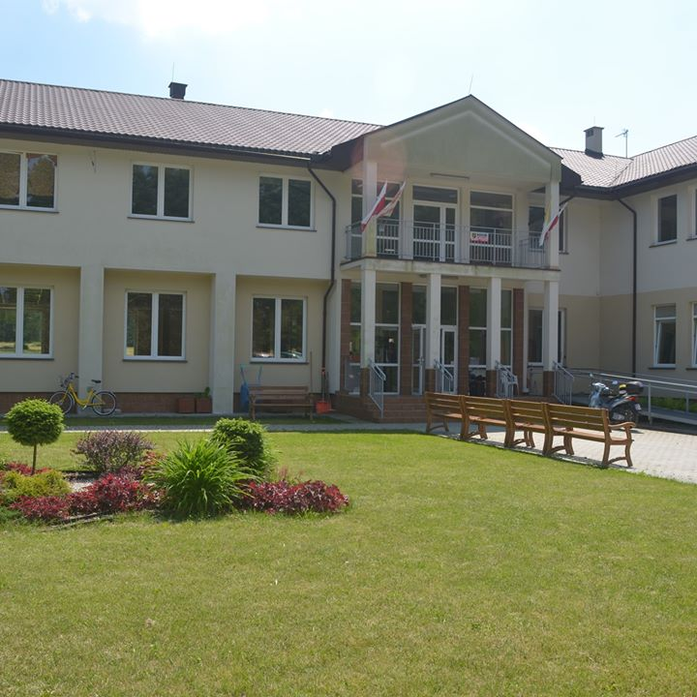

Working days: 20th July - 27th July 2020
Travel days: Arrival on 19th of July – Departure on 28th of July

The recruitment of participants lasts until 31.05.2020!!!

Number of participants:
- SFERA Srbija - Serbia – 10 participants
- Udruga Enas - Croatia – 10 participants
- Bosnian Representative Association for Valuable Opportunities - Bosnia and Herzegovina – 10 participants
- Solunian Brothers - Cyrill and Methodius Foundation - Poland - 10 participants
- Omladinska Parteska Aktivnost - Kosovo in accordance with the United Nations resolution - 6 participants.

Travel Budget:
Poland | 20 euros / participant
Serbia | 275 euros / participant
Croatia | 275 euros / participant
Bosnia and Herzegovina | 275 euros / participant
Kosovo in accordance with the United Nations resolution | 275 euros / participant

Travel costs reimbursement

Reimbursement is calculated based on the distance calculator of the European Commission.
At the arrival, all participants must provide flight reservation, all original tickets and boarding passes. They must send by post the return tickets and boarding passes to an email address which will be provided.
Travel costs will be reimbursed only for the cheapest means of transportation. Acceptable means of transportation for the project are: plane, bus, train, metro or ferry, NOT taxi and NOT car.
We don`t refund the costs for extra luggage (only checked baggage) and taxi journey!!!

The date of purchasing the tickets - until June 10, 2020!

CONTEXT

It has been noticed that the number of young people struggling with Digital Dementia is increasing. A large proportion of young people are unable to use new technologies for a useful purpose. Many of them are not able to use the smartphone for purposes other than social networking sites such as Facebook or Instagram. Apart from the basic functions, they cannot use it for any other purpose, e.g. use the phone to time management, increase their concentration and productivity.
Through an individual and group approach to young people and the results of research, it can be concluded that young people are increasingly turning to the phone "turning off thinking" exposing themselves to the risk of external factors, and this creates memory problems for young people.
Korean scientists indicate that this problem is largely related to technological progress (http://bit.ly/2miAVWc). In the era of rapidly developing technology, children spend more and more time communicating through digital devices, thanks to which their right hemisphere develops slowly.
Prof. Manfred Spitzer in his research states that young people's digital dementia is becoming more common. According to the report, the number of children aged 10-19 using a smartphone a minimum of 7 hours a day increased by 18%. Without intervention and raising awareness of young society, a young person may fail in the future. With age, their problems will increase, the lack of knowledge about the dangers of new technologies and at the same time the lack of knowledge about the development opportunities that a properly used smartphone can give will hinder their development and self-esteem. Realizing how extensive the problem is, analyzing its causes and effects, we decided to organize an exchange of young people who want to expand their knowledge about the healthy use of digital devices - in a way that will not harm, but improve their productivity, increase creativity and efficiency.
By participating, we want to help young people find their way into adult life, which they enter, and make them aware of the dangers of digital dementia. Participants will develop knowledge about new technologies, their possibilities and learn to use them to increase the effects of their daily work. Everyone will also develop self-confidence, motivation and leadership skills to share knowledge with others. They will talk about the root causes of digital dementia problems in their countries - about commonalities and differences. Young people are often unable to achieve their goals, lack confidence and believe in their skills. We will work on their self-presentation, attitude and ability to share knowledge. Living in a world of digitization, we need leaders who will show us how to properly navigate this world.
The youth exchange program will be based on non-formal and innovative education methods, its goals and assumptions will be based on the latest scientific research in the field of psychology.

Aims:

The aim is supported by the following objectives:
- training participants to use their smartphone effectively
- training participants in basic interpersonal skills
- training participants to increase their concentration in the age of digital noise
- training participants in the field of minimalism in the digital world
- training participants in increasing their productivity through the use of new technologies
- increasing the creativity, self-confidence and motivation of participants
- educating participants about digital dementia.

Selection process:
It will be performed by each organization, through a public appeal on the group email within the organization, so that the process is open and all members are informed about the project. However, it is agreed that if the coordinating organization sees the need, it has the right to request the applications submitted, to ensure transparency and eliminate possible conflicts of interest. Applicants will fill out a questionnaire that reveals the selection criteria. In order to validate the English knowledge, it is recommended to fill in the form in English.

Selection criteria:
- member (employee or volunteer) in the partner association
- basic knowledge of the concept of digital dementia
- readiness to continue further work in international youth projects
- basic knowledge of English (written, spoken)
- young people aged from 23 to 29 years.

Currency exchange
For those who wish to change their currency into POLISH ZLOTY, we suggest to do it at the airport as in this are you will have no possibility to do it.

Weather
It is warm and dry in Poland in July.
Temperature: at night 20-22 C°, day 26-29 C°.
WHAT TO BRING:
What to bring with you?
1) Information about topic from your country
2) Materials of your organization
3) Good mood
4) Medicines and insurance;
5) Original travel e-tickets and invoices like train tickets, bus tickets etc.
6) Laptop, (or/and) camera

Location:
Promotion Center NATURA 2000 in Budy Głogowskie
http://www.caritasrzeszow-natura2000.pl/?page_id=73
Budy Głogowskie 836 A
36-060 Głogów Małopolski
Poland

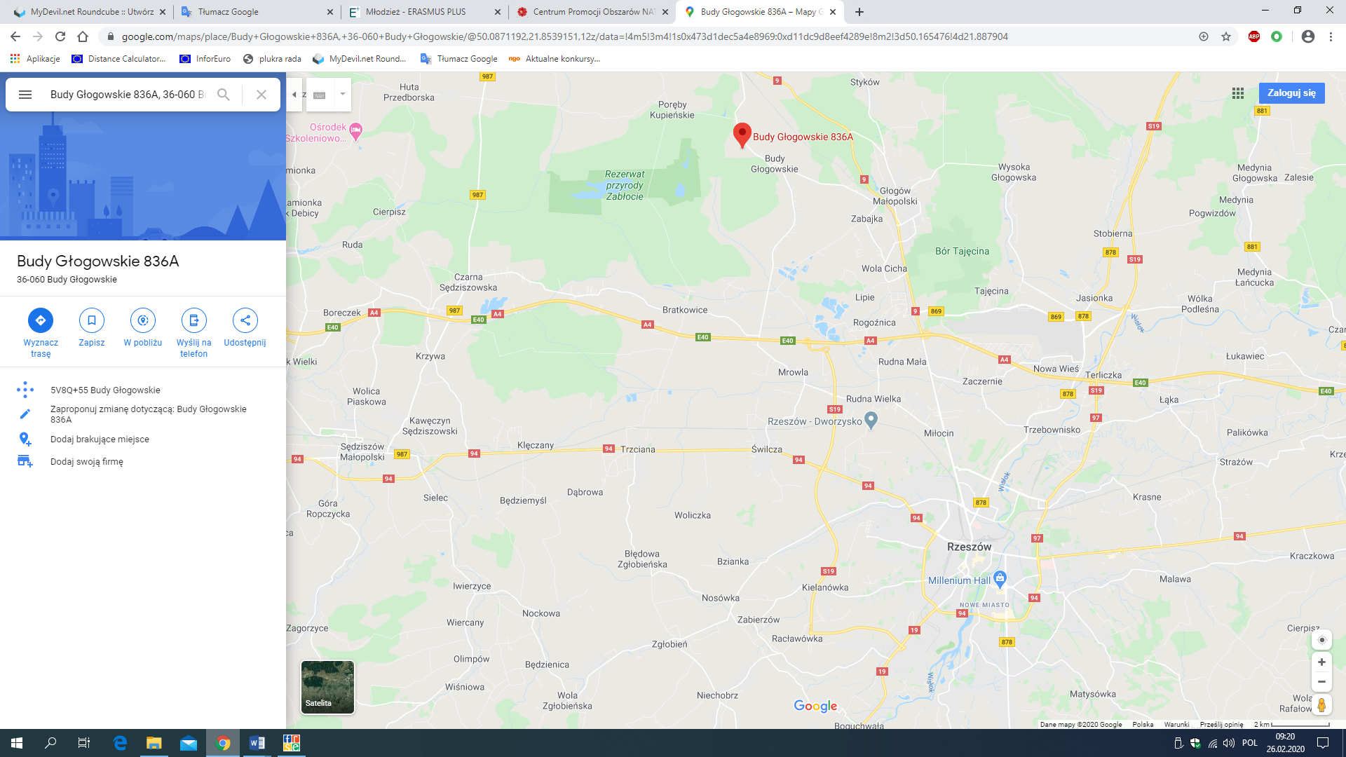
https://www.google.com/maps/place/Budy+G%C5%82ogowskie+836A,+36-060+Budy+G%C5%82ogowskie/@50.0871192,21.8539151,12z/data=!4m5!3m4!1s0x473d1dec5a4e8969:0xd11dc9d8eef4289e!8m2!3d50.165476!4d21.887904

How to reach Venue?
The nearest airports on the Polish side are in Kraków and Rzeszów-Jasionka. If the participants arrive to Rzeszów more or less on the same time, we will organize transport for them to their destination (Budy Głogowskie).

For more info, please contact: marek@fundacjacim.pl, iryna@fundacjacim.pl.

